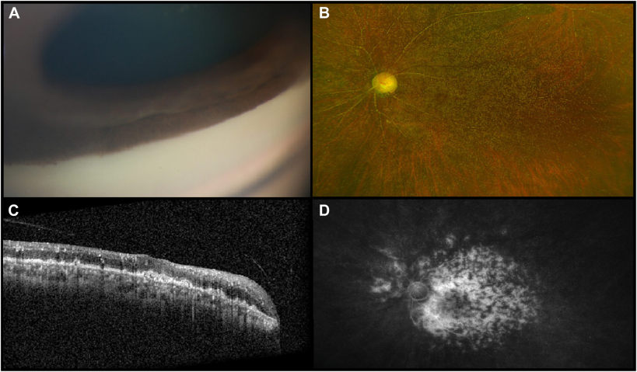

A 56-year-old woman presented with count fingers vision and significantly elevated intraocularpressures bilaterally. Examination revealed bilateral angle closure due to neovascular peripheral anterior synechiae (A), advanced optic disccupping, severe oxalate retinopathy, and attenuated, crystal-filled vessels (B). OCT of the macula showed crystal deposition in every retinallayer and hyperreflectivity and irregularity of the retinal pigment epithelium with overlying loss of the ellipsoid zone (C). Fluoresceinangiography demonstrated widespread vascular leakage (D). Based on the provided images and clinical description please make an ophthalmic diagnosis for this patient. And output the diagnostic conclusions only.

**Primary Hyperoxaluria**